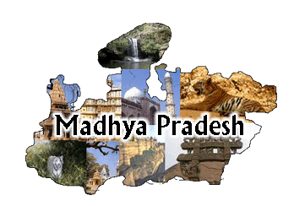
THINK MADHYA PRADESH FORUM
Think-tank for Pragmatic, Peaceful & Prosperous Madhya Pradesh
Office : Knowledge Partner
METROMIRROR.COM
Brainpower Media India Pvt. Ltd.
Prime Plaza, 3rd Floor, E–3/46 Arera Colony
10 No. Stop, Bhopal–462016 BHOPAL CHAPTER
EMAIL: thinkmadhyapradeshforum@gmail.com / editormetromirror@gmail.com
www.metromirror.com/prci.html
Phone: 9893096880, 2562882,4055957
APPLICATION FORM FOR MEMBERSHIP
Name (In block letter) Mr./Mrs.: ……………………………………………………Date of Birth ……/…../………..
Address : Residence: …………………………………………………………………………………………………………………
Office: ……………………………………………………………………………………………………………………………….
Telephone :Residence ………………………………………………. Office……………………………………………………
Email…………………………………………………………………………………………………………………………………………
Educational Qualification ………………………………………………..University………………….year………………
……………………………………………….. University………………... year……………..
Occupation / Experience (Past & Present) Attach Separate Sheet………………………………………………
Membership of other organization (if any) ……………………………………………………………………………..
Name of Spouse : Mrs./Mr. ………………………………………………….Occupation………………………………….
Date of marriage…………/……………./…………..No. of Children(If any)…….………………………………………
Areas of your expertise that you wish to contribute …………………………………………………………………..
……………………………………………………………………………………………………………………………………………………Proposed by: Name ……………………………………………………..Signature: ……………………………………………
Address :………………………………………………………………………Phone No. :………………………………………….
Seconded by Name : ………………………………………………………..Signature: …………………………………………
Address : ……………………………………………………………………. Phone no. :……………………………………………

----------------------------------------- -----------------------------------
Authorized Signature on behalf of Signature of Member
Corporate / Institutional Member(with seal) (Individual)
Approved/Not Approved :……………………………………………………………………………………………………………………..
Hon. Secretary : ………………………………………………………….Chairman : ……………………………………………………….
Welcome Kit Dispatched on: ……………………………………………………………………………………………………...
Membership No. Allotted: ………………………………………………………………………………………………………..
Online Media Partner

